Kamishibai Dialogue Check List:

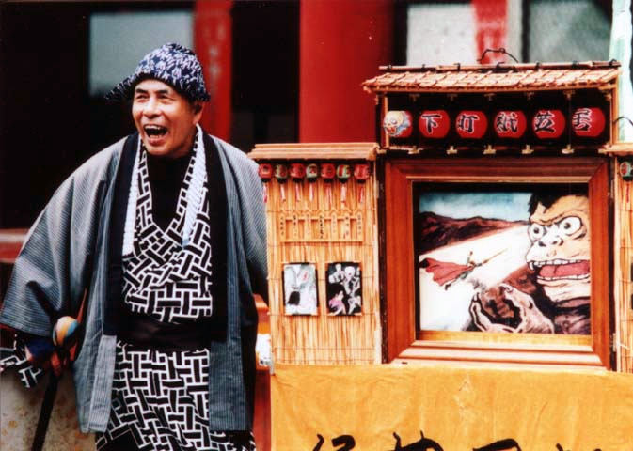

**_Main Character**

**_Character Names** *__****Give your characters names!*** *__****Make sure you SAY the names***

**_Setting** (If your character is walking through the snow you can shiver and mime walking on the line, “Sebastian wandered for days as the snow fell all around him. He looked everywhere.”)

_**Conflict**

**_Resolution**

**_Conclusion**

**_Active Dialogue** (Make the story feel as though it is happening now with present tense)

_**Mimed Narration** (members of the group who are not speaking can act out the panel scenes.)

_**Speak One or more Lines in Unison**

**TIPS for Strong Dialogue!**

__**Take a breath or dramatic pause** before an important part of the story

__**Show Emotion.**  *Think about what does the moment in each panel feel or smell like.*

**__Would an LE student understand the story?**

Remember Leonardo the Terrible Monster?  Think about how to make your dialogue active.  Members in your group can act out scenes to go along with the images.  Remember the game, "teacher I'm sorry I'm late" in this game several actors mimed what was happening while the student was explaining to the teacher what had happened.

**Who** *Who is you character?* *Who do they meet along the way?* **Why**  **Where**

**What** *What happens to them? What is the message—the moral?* **When**